Insert:
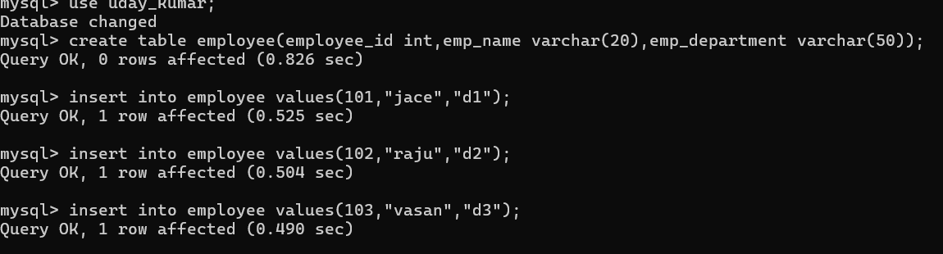
Select (All columns ):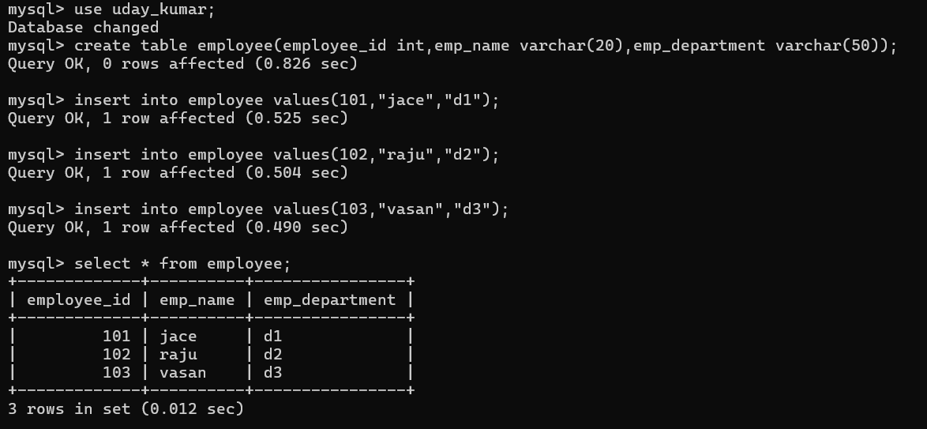
Select (specific columns):
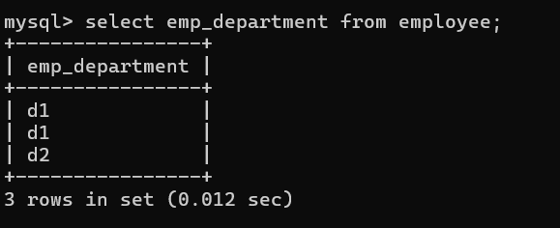

Select for where clause:
